

|  |
| --- |
| Lab 5 |

|  |  |  |
| --- | --- | --- |
| Portable Technologies in Cloud |  |  |
| **Professor: Irina Geiman**  Name: Niluxsi Puvanenthiran  CODE: CLO835 Student Number: 119163228 |  |  |

Contents

WEEK 6 – Lab 5 4

Workshop 1 – Deployment, Rollouts, Revisions and Rollbacks 4

Workshop 2 – Using Labels to Organize K8s Pods 7

Workshop 3 – Using K8s Services 8

Workshop 4 – DNS in K8s 15

References 18

Screenshot 1 Copied deployment file to the machine runnign kind K8s cluster 4

Screenshot 2 Logged to instance 4

Screenshot 3 working with deployment 5

Screenshot 4 Creating revisions 5

Screenshot 5 edit deployment 6

Screenshot 6 nginx successfully rolled out 6

Screenshot 7 edit deployment 6

Screenshot 8 updated deployment manifest from point to non-exixtent 6

Screenshot 9 pods replaced with new version 7

Screenshot 10 pods didnt terminated 7

Screenshot 11 Assigning labels to pods 7

Screenshot 12 using labels 7

Screenshot 13 Copied all deployment files to EC2 with kind cluster 8

Screenshot 14 logged in to ec2 8

Screenshot 15 name space created 8

Screenshot 16 deployed Mongo DB and verified the deployment 9

Screenshot 17 created service to expose mongo DB to internal clusters 9

Screenshot 18 examined service end points 10

Screenshot 19service to expose is created 10

Screenshot 20 created service is verified 11

Screenshot 21 forwarded local port 8080 to service port 80 with port-forward 11

Screenshot 22 verified the access to service 11

Screenshot 23 Access to port 12

Screenshot 24 Service type updated to nodeport 13

Screenshot 25 sg inbound rule modified 13

Screenshot 26 connected guestbook application with NodePort 13

Screenshot 27 still able to connect after changing nodeport 14

Screenshot 28 Changed the sg rule 14

Screenshot 29 not successful 14

Screenshot 30 Deleted Mongo Service 15

Screenshot 31 renamed the mongo service 15

Screenshot 32 Was not able to connect with ClusterIP after rename 15

Screenshot 33 Creating deployment for out http server 15

Screenshot 34 Deployment is exposed 16

Screenshot 35Access to the application tested successfully 16

Screenshot 36 Services and Endpoints 16

Screenshot 37 name server not found 17

# WEEK 6 – Lab 5

## Workshop 1 – Deployment, Rollouts, Revisions and Rollbacks

Screenshot Copied deployment file to the machine runnign kind K8s cluster

Screenshot Logged to instance

Screenshot working with deployment

There is only one roll out. As we deployed the deployment.apps/deployment-nginx for the first time, there is only one rollout history entry, representing the initial deployment.

Screenshot Creating revisions

Screenshot edit deployment

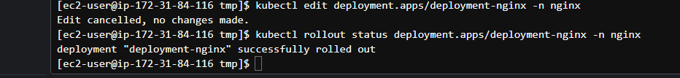

Screenshot nginx successfully rolled out

Screenshot 7 edit deployment

Screenshot updated deployment manifest from point to non-exixtent

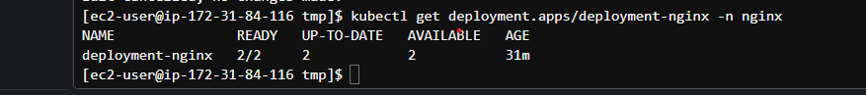

Screenshot pods replaced with new version

Screenshot pods didnt terminated

## Workshop 2 – Using Labels to Organize K8s Pods

Screenshot Assigning labels to pods

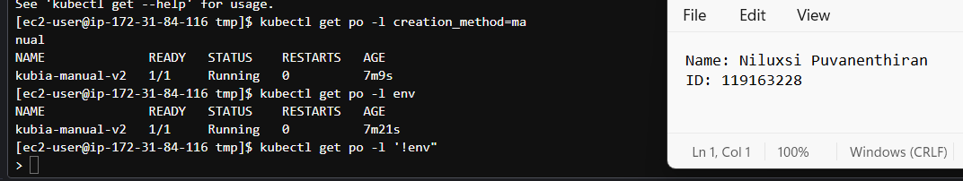

Screenshot using labels

## Workshop 3 – Using K8s Services

Screenshot Copied all deployment files to EC2 with kind cluster

Screenshot logged in to ec2

Screenshot name space created

Screenshot deployed Mongo DB and verified the deployment

Screenshot created service to expose mongo DB to internal clusters

**Explain**: what type of service did we create? Why is this the right type of service to use with Mongo DB?

ClusterIP Service was created. This type of service is ideal for load balancing

Screenshot examined service end points

Screenshot service to expose is created

Screenshot created service is verified

Screenshot forwarded local port 8080 to service port 80 with port-forward

Screenshot verified the access to service

Screenshot Access to port

It was not successful because ClusterIP is designed for internal communication within the cluster and does not provide external access.

Screenshot Service type updated to nodeport

The port fort is running

Screenshot sg inbound rule modified

Screenshot connected guestbook application with NodePort

Screenshot still able to connect after changing nodeport

Screenshot Changed the sg rule

Screenshot not successful

* **Would our application work if we give our MongoDB service a *different* name?**

It may or may not work depending on how the application is configured to connect to the MongoDB service.

Screenshot Deleted Mongo Service

Screenshot renamed the mongo service

Screenshot Was not able to connect with ClusterIP after rename

## Workshop 4 – DNS in K8s

Screenshot Creating deployment for out http server

Screenshot Deployment is exposed

Screenshot Access to the application tested successfully

Screenshot Services and Endpoints

Screenshot name server not found

# References

Geiman, I. (2023, Summer). Lectures and Slides, CLO835_Portable Technologies in cloud. Seneca Newham Campus, North York.

*Learner Lab*. (2023). Retrieved from https://awsacademy.instructure.com/.